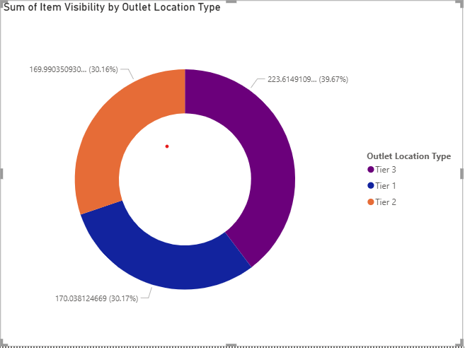

1. Most sales are coming from Tier 3 outlets. These locations contribute the highest sales numbers compared to Tier 2 and Tier 1. If you’re looking to focus your efforts, Tier 3 seems to be your best bet.
2. The average sale is $141, and this stays about the same no matter how you slice the data. This kind of consistency suggests your pricing and product mix are stable.

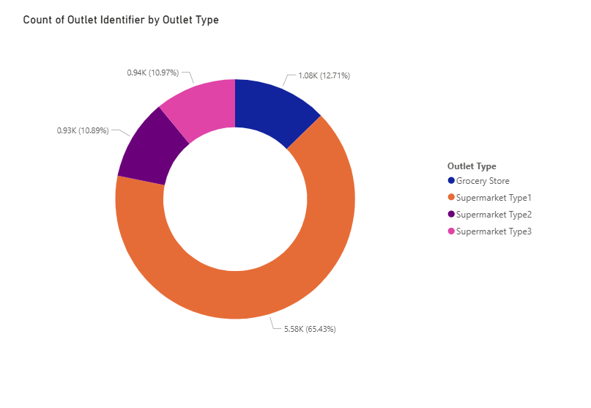

1. When it comes to types of stores, Grocery Stores and Supermarket Type1 pull in the biggest sales and have the broadest assortment. Supermarket Type3 and Type2 sell less overall but still contribute.

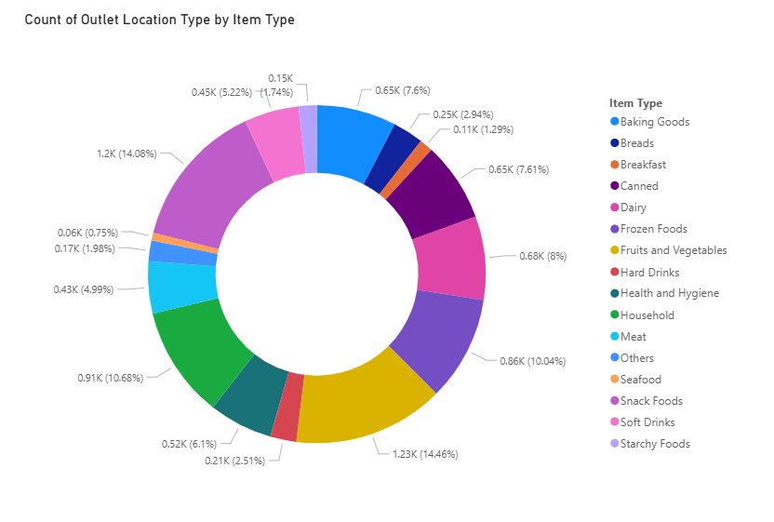

1. Across all your items, you have strong diversity in what’s selling, but certain categories like fruits, snacks, and breakfast items stand out with higher sales. Low fat products also make up a significant portion of sales, showing a healthy choices trend.

1. Your customer ratings hold steady at 3.9 out of 5, and the number of items sold across outlets is impressive, showing good customer interest.

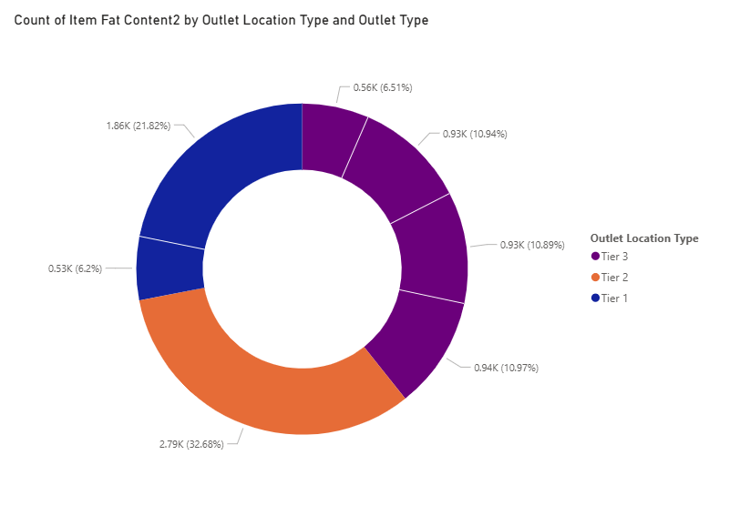

1. Tire 1 cities customers are more into healthy product than tire 2 and tire 3 cities. People are more health conscious in tire 1 > tire 2 > tire 3.